附件：

**框1　PubMed检索策略**

#1 "evidence based" [Title/Abstract] OR EBM [Title/Abstract] OR EBN [Title/Abstract] OR EBP [Title/Abstract] OR EBL [Title/Abstract] OR RBL [Title/Abstract] OR "research based" [Title/Abstract]

#2 teaching [Title/Abstract] OR education [Title/Abstract] OR learning [Title/Abstract]

#3 ("meta analysis" [Publication Type] OR "Meta-Analysis as Topic" [MeSH Terms] OR "Systematic Reviews as Topic" [MeSH Terms] OR "Systematic Review" [Publication Type] OR "meta analysis" [Title] OR "Systematic Review" [Title]) NOT "protocol" [Title]

#4 PG [Title/Abstract] OR UG [Title/Abstract] OR student [Title/Abstract] OR undergraduate [Title/Abstract] OR postgraduate [Title/Abstract]

#5 #1 AND #2 AND #3 AND #4

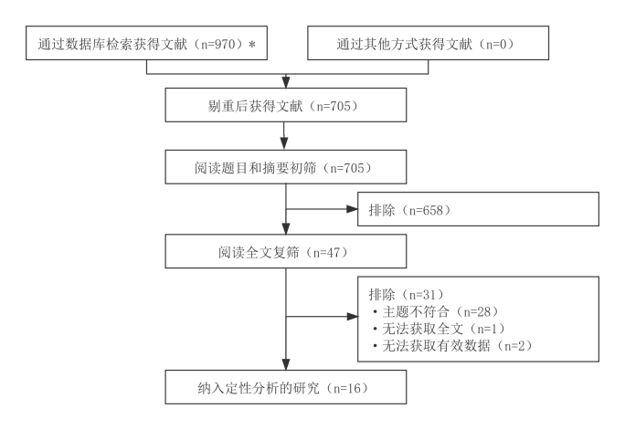

**图1　文献筛选流程及结果**

*所检索的数据库及检出文献数具体如下：PubMed（*n*=134）、Web of Science（*n*=339）、Cochrane Library（*n*=8）、EMbase（*n*=72）、CNKI（*n*=114）、WanFang Data（*n*=99）、CBM（*n*=95）和VIP（*n*=109）